Deep Learning

**Index**

|  |  |  |  |
| --- | --- | --- | --- |
| **Sr. No** | **Title** | **Date** | **Sign** |
| 1. | Performing matrix multiplication and finding eigen vectors and eigen values using TensorFlow. |  |  |
| 2. | Solving XOR problem using deep feed forward network. |  |  |
| 3. | Implementing deep neural network for performing binary classification task |  |  |
| 4. | a) Aim: Using deep feed forward network with two hidden layers for performing multiclass classification and predicting the class.  b) Aim: Using a deep feed forward network with two hidden layers for performing classification and predicting the probability of class.  c) Aim: Using a deep feed forward network with two hidden layers for performing linear regression and predicting values. |  |  |
| 5. | Evaluating feed forward deep network for regression using KFold cross validation. |  |  |
| 6. | Implementing regularization to avoid overfitting in binary classification. |  |  |
| 7. | Demonstrate recurrent neural network that learns to perform sequence analysis. |  |  |
| 8. | Performing encoding & decoding of images autoencoder. |  |  |
| 9. | Implementation of convolutional neural network to predict numbers from number images |  |  |
| 10. | Denoising of images using autoencoder. |  |  |

**Practical No: 1**

**Aim:** Performing matrix multiplication and finding eigen vectors and eigen values using TensorFlow.

**Code:**

import tensorflow as tf

print("Matrix Multiplication Demo")

x=tf.constant([1,2,3,4,5,6],shape=[2,3])

print(x)

y=tf.constant([7,8,9,10,11,12],shape=[3,2])

print(y)

z=tf.matmul(x,y)

print("Product:",z)

e_matrix_A=tf.random.uniform([2,2],minval=3,maxval=10,dtype=tf.float32,name="matrixA")

print("Matrix A:\n{}\n\n".format(e_matrix_A))

eigen_values_A,eigen_vectors_A=tf.linalg.eigh(e_matrix_A)

print("Eigen Vectors:\n{}\n\nEigen Values:\n{}\n".format(eigen_vectors_A,eigen_values_A))

**Output:**

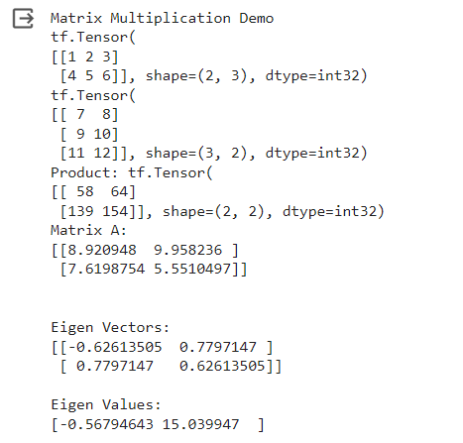

**Practical No: 2**

**Aim:** Solving XOR problem using deep feed forward network.

**Code:**

import numpy as np

def unitStep(v):

if v >= 0:

return 1

else:

return 0

def perceptronModel(x, w, b):

v = np.dot(w, x) + b

y = unitStep(v)

return y

def NOT_logicFunction(x):

wNOT = -1

bNOT = 0.5

return perceptronModel(x, wNOT, bNOT)

def AND_logicFunction(x):

w = np.array([1, 1])

bAND = -1.5

return perceptronModel(x, w, bAND)

def OR_logicFunction(x):

w = np.array([1, 1])

bOR = -0.5

return perceptronModel(x, w, bOR)

def XOR_logicFunction(x):

y1 = AND_logicFunction(x)

y2 = OR_logicFunction(x)

y3 = NOT_logicFunction(y1)

final_x = np.array([y2, y3])

finalOutput = AND_logicFunction(final_x)

y3 = NOT_logicFunction(y1)

return finalOutput

test1 = np.array([0, 1])

test2 = np.array([1, 1])

test3 = np.array([0, 0])

test4 = np.array([1, 0])

print("XOR({}, {}) = {}".format(0, 1, XOR_logicFunction(test1)))

print("XOR({}, {}) = {}".format(1, 1, XOR_logicFunction(test2)))

print("XOR({}, {}) = {}".format(0, 0, XOR_logicFunction(test3)))

print("XOR({}, {}) = {}".format(1, 0, XOR_logicFunction(test4)))

**Output:**

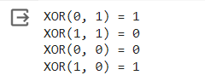

**Practical No: 3**

**Aim:** Implementing deep neural network for performing binary classification task.

**Code:**

import pandas as pd

from keras.models import Sequential

from keras.layers import Dense

from scikeras.wrappers import KerasClassifier

from sklearn.model_selection import cross_val_score

from sklearn.preprocessing import LabelEncoder

from sklearn.model_selection import StratifiedKFold

from sklearn.preprocessing import StandardScaler

from sklearn.pipeline import Pipeline

# load dataset

dataframe = pd.read_csv("//content//sonar.all-data", header=None)

dataset = dataframe.values

# split into input (X) and output (Y) variables

X = dataset[:,0:60].astype(float)

Y = dataset[:,60]

# encode class values as integers

encoder = LabelEncoder()

encoder.fit(Y)

encoded_Y = encoder.transform(Y)

# baseline model

def create_baseline():

# create model

model = Sequential()

model.add(Dense(60, input_dim=60, activation='relu'))

model.add(Dense(1, activation='sigmoid'))

# Compile model

model.compile(loss='binary_crossentropy', optimizer='adam', metrics=['accuracy'])

return model

# evaluate model with standardized dataset

estimator = KerasClassifier(build_fn=create_baseline, epochs=100, batch_size=5, verbose=0)

kfold = StratifiedKFold(n_splits=10, shuffle=True)

results = cross_val_score(estimator, X, encoded_Y, cv=kfold)

print("Baseline: %.2f%% (%.2f%%)" % (results.mean()*100, results.std()*100))

# evaluate baseline model with standardized dataset

estimators = []

estimators.append(('standardize', StandardScaler()))

estimators.append(('mlp', KerasClassifier(build_fn=create_baseline, epochs=100, batch_size=5, verbose=0)))

pipeline = Pipeline(estimators)

kfold = StratifiedKFold(n_splits=10, shuffle=True)

results = cross_val_score(pipeline, X, encoded_Y, cv=kfold)

print("Standardized: %.2f%% (%.2f%%)" % (results.mean()*100, results.std()*100))

def create_smaller():

# create model

model = Sequential()

model.add(Dense(30, input_dim=60, activation='relu'))

model.add(Dense(1, activation='sigmoid'))

model.compile(loss='binary_crossentropy', optimizer='adam', metrics=['accuracy'])

return model

estimators = []

estimators.append(('standardize', StandardScaler()))

estimators.append(('mlp', KerasClassifier(build_fn=create_smaller, epochs=100, batch_size=5, verbose=0)))

pipeline = Pipeline(estimators)

kfold = StratifiedKFold(n_splits=10, shuffle=True)

results = cross_val_score(pipeline, X, encoded_Y, cv=kfold)

print("Smaller: %.2f%% (%.2f%%)" % (results.mean()*100, results.std()*100))

# larger model

def create_larger():

# create model

model = Sequential()

model.add(Dense(60, input_dim=60, activation='relu'))

model.add(Dense(30, activation='relu'))

model.add(Dense(1, activation='sigmoid'))

# Compile model

model.compile(loss='binary_crossentropy', optimizer='adam', metrics=['accuracy'])

return model

estimators = []

estimators.append(('standardize', StandardScaler()))

estimators.append(('mlp', KerasClassifier(build_fn=create_larger, epochs=100, batch_size=5, verbose=0)))

pipeline = Pipeline(estimators)

kfold = StratifiedKFold(n_splits=10, shuffle=True)

results = cross_val_score(pipeline, X, encoded_Y, cv=kfold)

print("Larger: %.2f%% (%.2f%%)" % (results.mean()*100, results.std()*100))

**Output:**

Baseline: 82.69% (9.24%)

Standardized: 87.52% (7.73%)

Smaller: 83.12% (5.11%)

Larger: 86.10% (7.49%)

**Practical No: 4**

**Aim:** A]Using deep feed forward network with two hidden layers for performing multiclass classification and predicting the class.

**Code:**

from keras.models import Sequential

from keras.layers import Dense

from sklearn.datasets import make_blobs

from sklearn.preprocessing import MinMaxScaler

X,Y=make_blobs(n_samples=100,centers=2,n_features=2,random_state=1)

scalar=MinMaxScaler()

scalar.fit(X)

X=scalar.transform(X)

model=Sequential()

model.add(Dense(4,input_dim=2,activation='relu'))

model.add(Dense(4,activation='relu'))

model.add(Dense(1,activation='sigmoid'))

model.compile(loss='binary_crossentropy',optimizer='adam')

model.summary()

model.fit(X,Y,epochs=200)

Xnew,Yreal=make_blobs(n_samples=3,centers=2,n_features=2,random_state=1)

Xnew=scalar.transform(Xnew)

Yclass=model.predict(Xnew)

import numpy as np

def predict_prob(number):

return [number[0],1-number[0]]

y_prob = np.array(list(map(predict_prob, model.predict(Xnew))))

y_prob

for i in range(len(Xnew)):

print("X=%s,Predicted_probability=%s,Predicted_class=%s"%(Xnew[i],y_prob[i],Yclass[i]))

#second way

predict_prob=model.predict([Xnew])

predict_classes=np.argmax(predict_prob,axis=1)

predict_classes

**Output:**

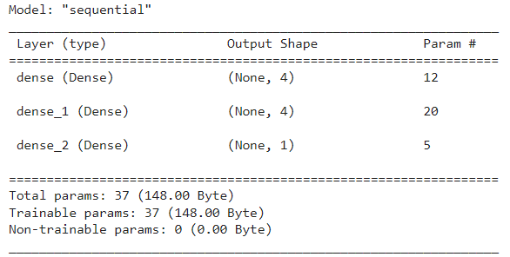







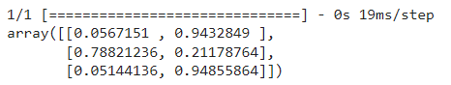





**Aim:** B]Using a deep feed forward network with two hidden layers for performing classification and predicting the probability of class.

**Code:**

from keras.models import Sequential

from keras.layers import Dense

from sklearn.datasets import make_blobs

from sklearn.preprocessing import MinMaxScaler

X,Y=make_blobs(n_samples=100,centers=2,n_features=2,random_state=1)

scalar=MinMaxScaler()

scalar.fit(X)

X=scalar.transform(X)

model=Sequential()

model.add(Dense(4,input_dim=2,activation='relu'))

model.add(Dense(4,activation='relu'))

model.add(Dense(1,activation='sigmoid'))

model.compile(loss='binary_crossentropy',optimizer='adam')

model.fit(X,Y,epochs=500)

Xnew,Yreal=make_blobs(n_samples=3,centers=2,n_features=2,random_state=1)

Xnew=scalar.transform(Xnew)

Ynew=model.predict(Xnew)

for i in range(len(Xnew)):

print("X=%s,Predicted=%s,Desired=%s"%(Xnew[i],Ynew[i],Yreal[i]))

**Output:**

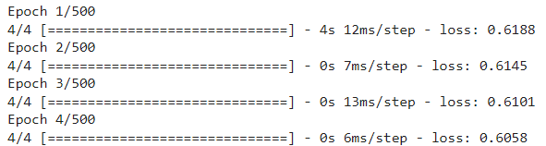

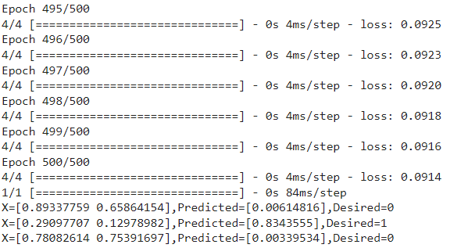

**Aim:** C]Using a deep feed forward network with two hidden layers for performing linear regression and predicting values.

**Code:**

from keras.models import Sequential

from keras.layers import Dense

from sklearn.datasets import make_regression

from sklearn.preprocessing import MinMaxScaler

X,Y=make_regression(n_samples=100,n_features=2,noise=0.1,random_state=1)

scalarX,scalarY=MinMaxScaler(),MinMaxScaler()

scalarX.fit(X)

scalarY.fit(Y.reshape(100,1))

X=scalarX.transform(X)

Y=scalarY.transform(Y.reshape(100,1))

model=Sequential()

model.add(Dense(4,input_dim=2,activation='relu'))

model.add(Dense(4,activation='relu'))

model.add(Dense(1,activation='sigmoid'))

model.compile(loss='mse',optimizer='adam')

model.fit(X,Y,epochs=1000,verbose=0)

Xnew,a=make_regression(n_samples=3,n_features=2,noise=0.1,random_state=1)

Xnew=scalarX.transform(Xnew)

Ynew=model.predict(Xnew)

for i in range(len(Xnew)):

print("X=%s,Predicted=%s"%(Xnew[i],Ynew[i]))

**Output:**

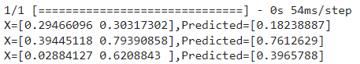

**Practical No: 5**

**Aim:** Evaluating feed forward deep network for regression using KFold cross validation.

**Code:**

from tensorflow.keras.datasets import cifar10

from tensorflow.keras.models import Sequential

from tensorflow.keras.layers import Dense, Flatten, Conv2D, MaxPooling2D

from tensorflow.keras.losses import sparse_categorical_crossentropy

from tensorflow.keras.optimizers import Adam

import matplotlib.pyplot as plt

# Model configuration

batch_size = 50

img_width, img_height, img_num_channels = 32, 32, 3

loss_function = sparse_categorical_crossentropy

no_classes = 100

no_epochs = 10 # you can increase it to 20,50,70, 100

optimizer = Adam()

verbosity = 1

# Load CIFAR-10 data

(input_train, target_train), (input_test, target_test) = cifar10.load_data()

# Determine shape of the data

input_shape = (img_width, img_height, img_num_channels)

# Parse numbers as floats

input_train = input_train.astype('float32')

input_test = input_test.astype('float32')

# Normalize data

input_train = input_train / 255

input_test = input_test / 255

# Create the model

model = Sequential()

model.add(Conv2D(32, kernel_size=(3, 3), activation='relu', input_shape=input_shape))

model.add(MaxPooling2D(pool_size=(2, 2)))

model.add(Conv2D(64, kernel_size=(3, 3), activation='relu'))

model.add(MaxPooling2D(pool_size=(2, 2)))

model.add(Flatten())

model.add(Dense(256, activation='relu'))

model.add(Dense(128, activation='relu'))

model.add(Dense(no_classes, activation='softmax'))

model.summary()

# Compile the model

model.compile(loss=loss_function, optimizer=optimizer,metrics=['accuracy'])

# Fit data to model (this will take little time to train)

history = model.fit(input_train, target_train, batch_size=batch_size, epochs=no_epochs, verbose=verbosity)

# Generate generalization metrics

score = model.evaluate(input_test, target_test, verbose=0)

print(f'Test loss: {score[0]} / Test accuracy: {score[1]}')

# Visualize history

# Plot history: Loss

plt.plot(history.history['loss'])

plt.title('Validation loss history')

plt.ylabel('Loss value')

plt.xlabel('No. epoch')

plt.show()

# Plot history: Accuracy

plt.plot(history.history['accuracy'])

plt.title('Validation accuracy history')

plt.ylabel('Accuracy value (%)')

plt.xlabel('No. epoch')

plt.show()

# By Adding k fold cross validation

from tensorflow.keras.datasets import cifar10

from tensorflow.keras.models import Sequential

from tensorflow.keras.layers import Dense, Flatten, Conv2D, MaxPooling2D

from tensorflow.keras.losses import sparse_categorical_crossentropy

from tensorflow.keras.optimizers import Adam

from sklearn.model_selection import KFold

KFold

import numpy as np

# Model configuration

batch_size = 50

img_width, img_height, img_num_channels = 32, 32, 3

loss_function = sparse_categorical_crossentropy

no_classes = 100

no_epochs = 10

optimizer = Adam()

verbosity = 1

num_folds = 5

# Load CIFAR-10 data

(input_train, target_train), (input_test, target_test) = cifar10.load_data()

# Determine shape of the data

input_shape = (img_width, img_height, img_num_channels)

# Parse numbers as floats

input_train = input_train.astype('float32')

input_test = input_test.astype('float32')

# Normalize data

input_train = input_train / 255

input_test = input_test / 255

# Define per-fold score containers

acc_per_fold = []

loss_per_fold = []

# Merge inputs and targets

inputs = np.concatenate((input_train, input_test), axis=0)

targets = np.concatenate((target_train, target_test), axis=0)

# Define the K-fold Cross Validator

kfold = KFold(n_splits=num_folds, shuffle=True)

# K-fold Cross Validation model evaluation

fold_no = 1

for train, test in kfold.split(inputs, targets):

# Define the model architecture

model = Sequential()

model.add(Conv2D(32, kernel_size=(3, 3), activation='relu', input_shape=input_shape))

model.add(MaxPooling2D(pool_size=(2, 2)))

model.add(Conv2D(64, kernel_size=(3, 3), activation='relu'))

model.add(MaxPooling2D(pool_size=(2, 2)))

model.add(Flatten())

model.add(Dense(256, activation='relu'))

model.add(Dense(128, activation='relu'))

model.add(Dense(no_classes, activation='softmax'))

# Compile the model

model.compile(loss=loss_function,

optimizer=optimizer,

metrics=['accuracy'])

# Generate a print

print('------------------------------------------------------------------------')

print(f'Training for fold {fold_no} ...')

# Fit data to model

history = model.fit(inputs[train], targets[train],

batch_size=batch_size,

epochs=no_epochs,

verbose=verbosity)

# Generate generalization metrics

scores = model.evaluate(inputs[test], targets[test], verbose=0)

print(f'Score for fold {fold_no}: {model.metrics_names[0]} of {scores[0]}; {model.metrics_names[1]} of {scores[1]*100}%')

acc_per_fold.append(scores[1] * 100)

loss_per_fold.append(scores[0])

# Increase fold number

fold_no = fold_no + 1

# == Provide average scores ==

print('------------------------------------------------------------------------')

print('Score per fold')

for i in range(0, len(acc_per_fold)):

print('------------------------------------------------------------------------')

print(f'> Fold {i+1} - Loss: {loss_per_fold[i]} - Accuracy: {acc_per_fold[i]}%')

print('------------------------------------------------------------------------')

print('Average scores for all folds:')

print(f'> Accuracy: {np.mean(acc_per_fold)} (+- {np.std(acc_per_fold)})')

print(f'> Loss: {np.mean(loss_per_fold)}')

print('------------------------------------------------------------------------')

**Output:**

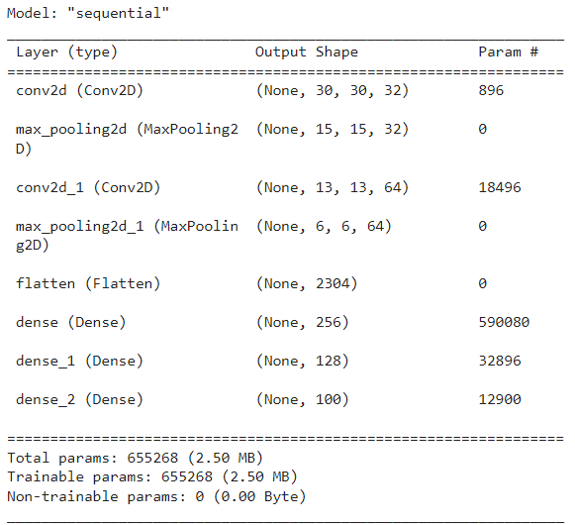



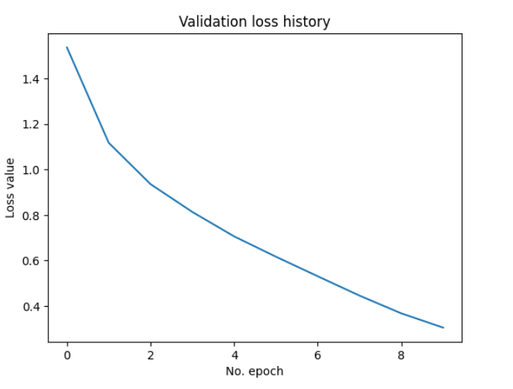

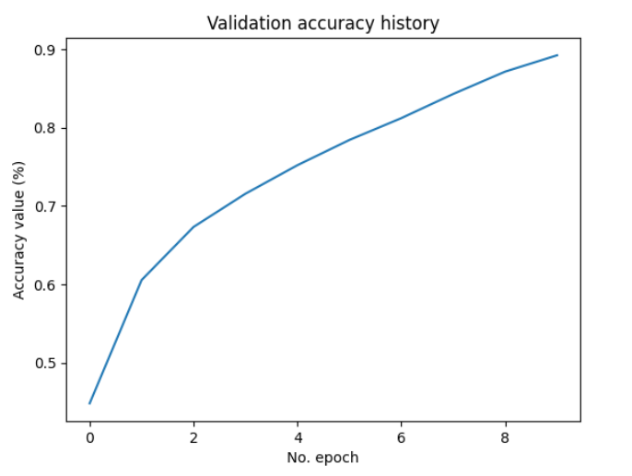

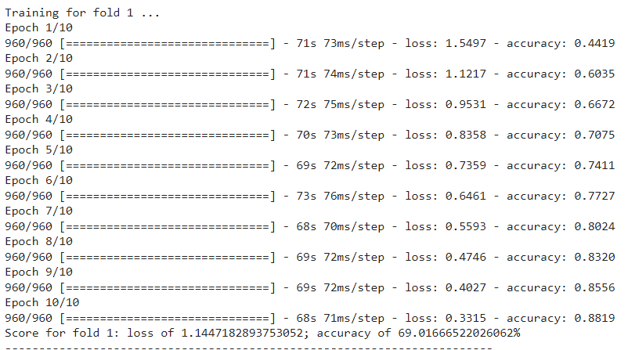

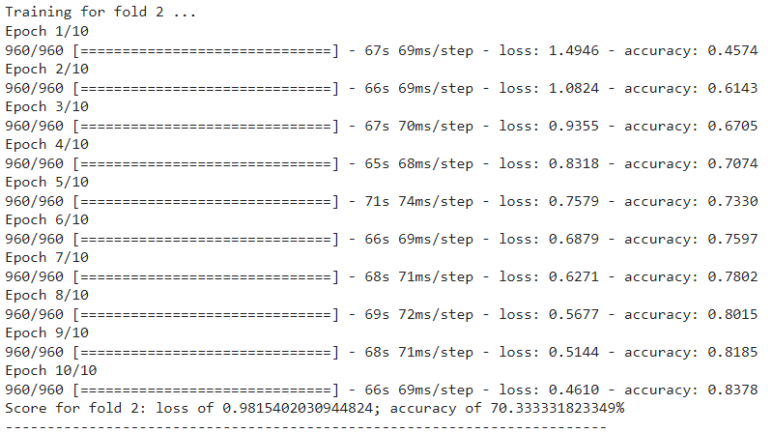

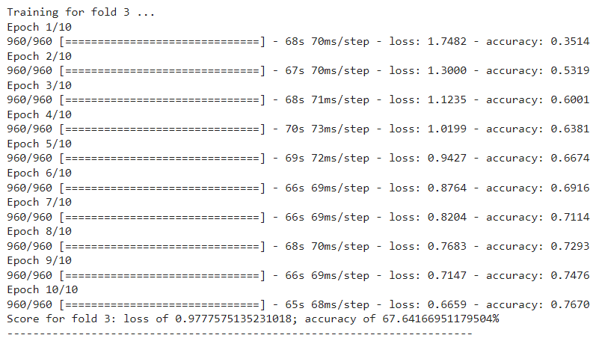

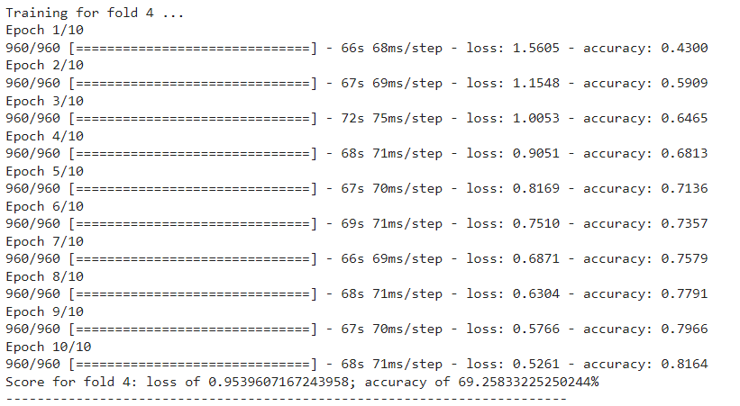

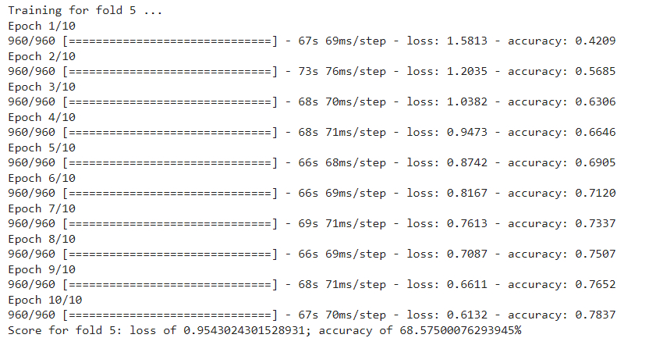

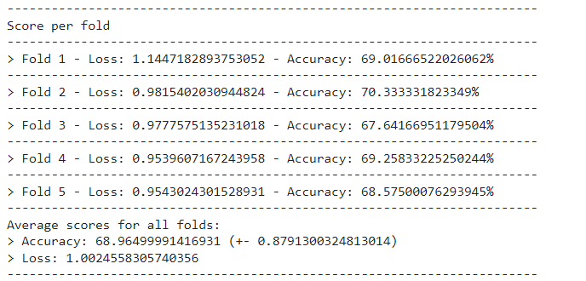

**Practical No: 6**

**Aim:** Implementing regularization to avoid overfitting in binary classification.

**Code:**

from matplotlib import pyplot

from sklearn.datasets import make_moons

from keras.models import Sequential

from keras.layers import Dense

X,Y=make_moons(n_samples=100,noise=0.2,random_state=1)

n_train=30

trainX,testX=X[:n_train,:],X[n_train:]

trainY,testY=Y[:n_train],Y[n_train:]

print(trainX.shape)

print(trainY.shape)

print(testX.shape)

print(testY.shape)

model=Sequential()

model.add(Dense(500,input_dim=2,activation='relu'))

model.add(Dense(1,activation='sigmoid'))

model.compile(loss='binary_crossentropy',optimizer='adam',metrics=['accuracy'])

model.summary()

history=model.fit(trainX,trainY,validation_data=(testX,testY),epochs=100)

pyplot.plot(history.history['accuracy'],label='train')

pyplot.plot(history.history['val_accuracy'],label='test')

pyplot.legend()

pyplot.show()

from keras.regularizers import l2

model=Sequential()

model.add(Dense(500,input_dim=2,activation='relu',kernel_regularizer=l2(0.001)))

model.add(Dense(1,activation='sigmoid'))

model.summary()

model.compile(loss='binary_crossentropy',optimizer='adam',metrics=['accuracy'])

history=model.fit(trainX,trainY,validation_data=(testX,testY),epochs=100)

pyplot.plot(history.history['accuracy'],label='train')

pyplot.plot(history.history['val_accuracy'],label='test')

pyplot.legend()

pyplot.show()

from keras.regularizers import l1_l2

model=Sequential()

model.add(Dense(500,input_dim=2,activation='relu',kernel_regularizer=l1_l2(l1=0.001,l2=0.001)))

model.add(Dense(1,activation='sigmoid'))

model.compile(loss='binary_crossentropy',optimizer='adam',metrics=['accuracy'])

model.summary()

history=model.fit(trainX,trainY,validation_data=(testX,testY),epochs=100)

pyplot.plot(history.history['accuracy'],label='train')

pyplot.plot(history.history['val_accuracy'],label='test')

pyplot.legend()

pyplot.show()

**Output:**

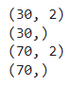

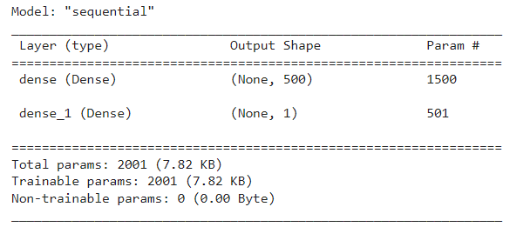

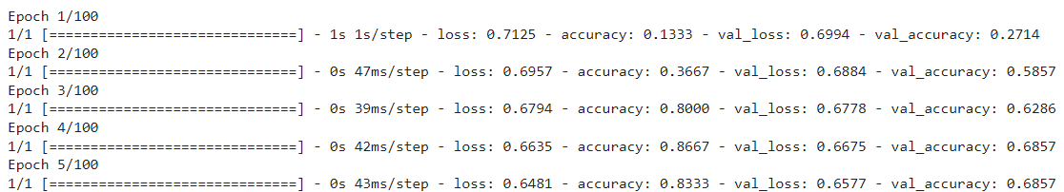

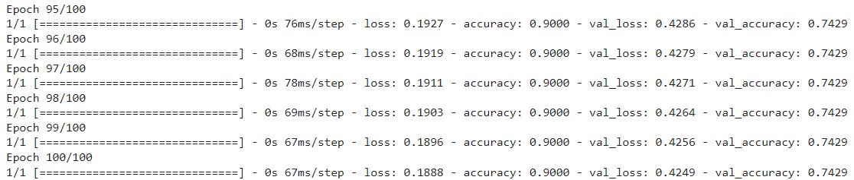

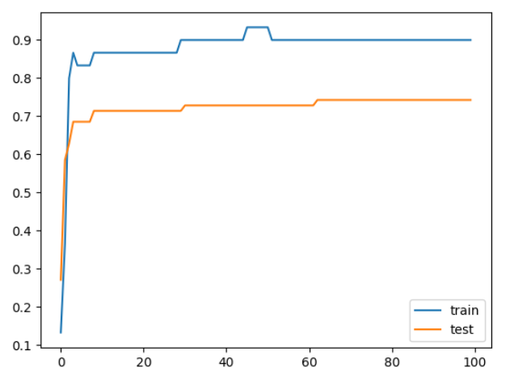

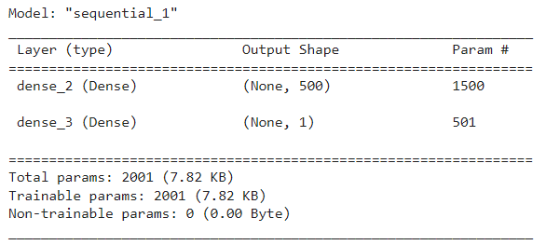

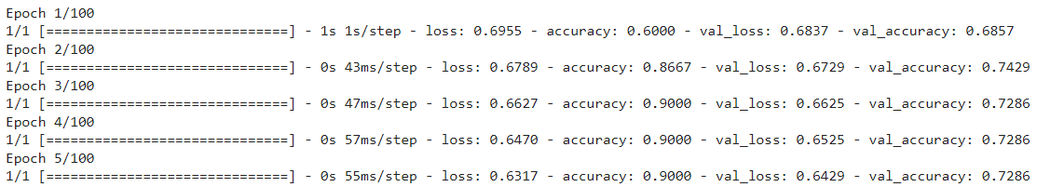

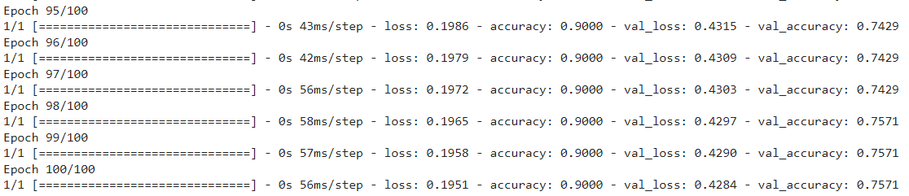

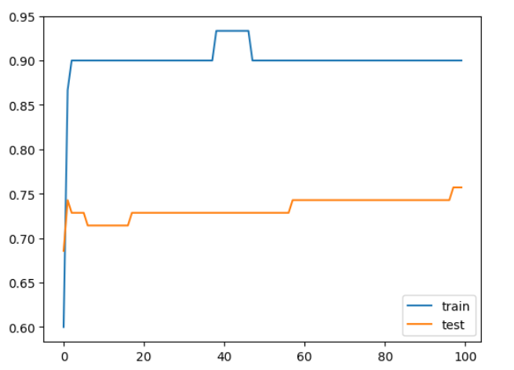

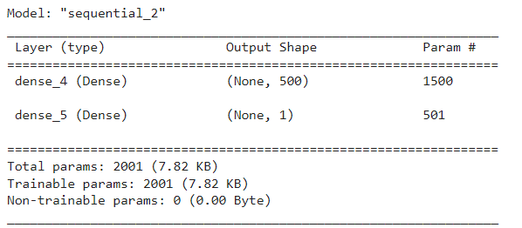

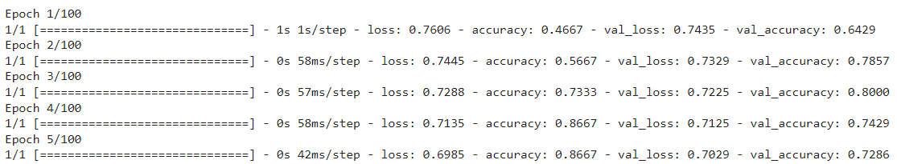

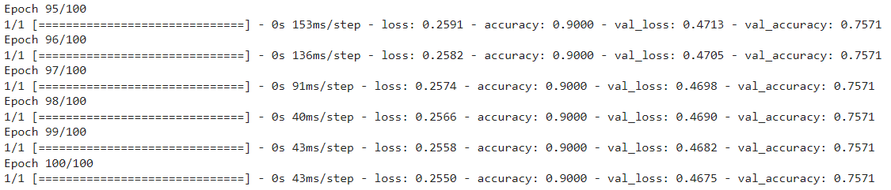

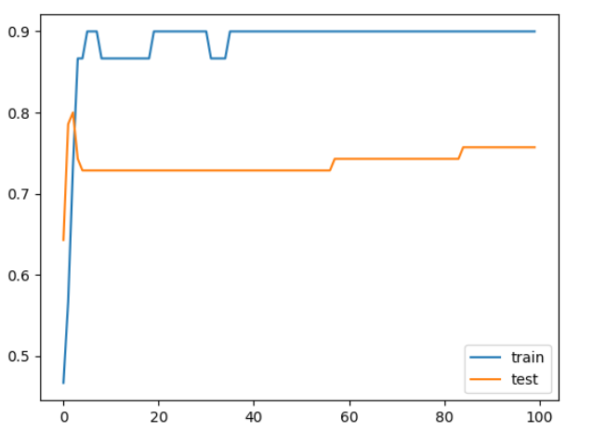

**Practical No: 7**

**Aim:** Demonstrate recurrent neural network that learns to perform sequence analysis.

**Code:**

import numpy as np

import tensorflow_datasets as tfds

import tensorflow as tf

tfds.disable_progress_bar()

import matplotlib.pyplot as plt

def plot_graphs(history, metric):

plt.plot(history.history[metric])

plt.plot(history.history['val_'+metric], '')

plt.xlabel("Epochs")

plt.ylabel(metric)

plt.legend([metric, 'val_'+metric])

dataset, info = tfds.load('imdb_reviews', with_info=True,

as_supervised=True)

train_dataset, test_dataset = dataset['train'], dataset['test']

train_dataset.element_spec

for example, label in train_dataset.take(5):

print('text: ', example.numpy())

print('label: ', label.numpy())

BUFFER_SIZE = 10000

BATCH_SIZE = 64

train_dataset = train_dataset.shuffle(BUFFER_SIZE).batch(BATCH_SIZE).prefetch(tf.data.AUTOTUNE)

test_dataset = test_dataset.batch(BATCH_SIZE).prefetch(tf.data.AUTOTUNE)

for example, label in train_dataset.take(1):

print('texts: ', example.numpy()[:3])

print()

print('labels: ', label.numpy()[:3])

VOCAB_SIZE = 1000

encoder = tf.keras.layers.TextVectorization(max_tokens=VOCAB_SIZE)

encoder.adapt(train_dataset.map(lambda text, label: text))

vocab = np.array(encoder.get_vocabulary())

vocab[:20]

encoded_example = encoder(example)[:3].numpy()

encoded_example

for n in range(3):

print("Original: ", example[n].numpy())

print("Round-trip: ", " ".join(vocab[encoded_example[n]]))

print()

model = tf.keras.Sequential([

encoder,

tf.keras.layers.Embedding(

input_dim=len(encoder.get_vocabulary()),

output_dim=64,

# Use masking to handle the variable sequence lengths

mask_zero=True),

tf.keras.layers.Bidirectional(tf.keras.layers.LSTM(64)),

tf.keras.layers.Dense(64, activation='relu'),

tf.keras.layers.Dense(1)

])

print([layer.supports_masking for layer in model.layers])

# predict on a sample text without padding.

sample_text = ('The movie was cool. The animation and the graphics '

'were out of this world. I would recommend this movie.')

predictions = model.predict(np.array([sample_text]))

print(predictions[0])

# predict on a sample text with padding

padding = "the " * 2000

predictions = model.predict(np.array([sample_text, padding]))

print(predictions[0])

model.compile(loss=tf.keras.losses.BinaryCrossentropy(from_logits=True),

optimizer=tf.keras.optimizers.Adam(1e-4),

metrics=['accuracy'])

history = model.fit(train_dataset, epochs=10,

validation_data=test_dataset,

validation_steps=30)

test_loss, test_acc = model.evaluate(test_dataset)

print('Test Loss:', test_loss)

print('Test Accuracy:', test_acc)

plt.figure(figsize=(16, 8))

plt.subplot(1, 2, 1)

plot_graphs(history, 'accuracy')

plt.ylim(None, 1)

plt.subplot(1, 2, 2)

plot_graphs(history, 'loss')

plt.ylim(0, None)

sample_text = ('The movie was cool. The animation and the graphics '

'were out of this world. I would recommend this movie.')

predictions = model.predict(np.array([sample_text]))

predictions

model = tf.keras.Sequential([

encoder,

tf.keras.layers.Embedding(len(encoder.get_vocabulary()), 64, mask_zero=True),

tf.keras.layers.Bidirectional(tf.keras.layers.LSTM(64, return_sequences=True)),

tf.keras.layers.Bidirectional(tf.keras.layers.LSTM(32)),

tf.keras.layers.Dense(64, activation='relu'),

tf.keras.layers.Dropout(0.5),

tf.keras.layers.Dense(1)

])

model.compile(loss=tf.keras.losses.BinaryCrossentropy(from_logits=True),

optimizer=tf.keras.optimizers.Adam(1e-4),

metrics=['accuracy'])

history = model.fit(train_dataset, epochs=10,

validation_data=test_dataset,

validation_steps=30)

test_loss, test_acc = model.evaluate(test_dataset)

print('Test Loss:', test_loss)

print('Test Accuracy:', test_acc)

# predict on a sample text without padding.

sample_text = ('The movie was not good. The animation and the graphics '

'were terrible. I would not recommend this movie.')

predictions = model.predict(np.array([sample_text]))

print(predictions)

plt.figure(figsize=(16, 6))

plt.subplot(1, 2, 1)

plot_graphs(history, 'accuracy')

plt.subplot(1, 2, 2)

plot_graphs(history, 'loss')

**Output:**

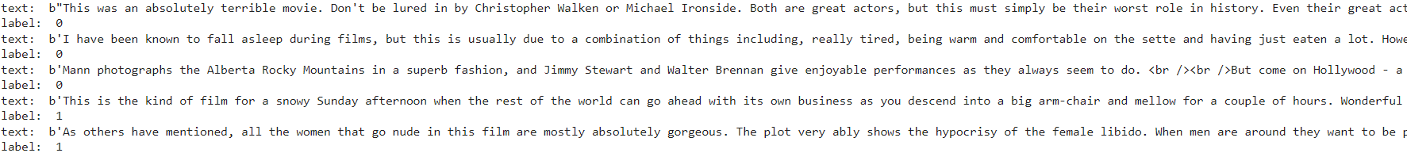

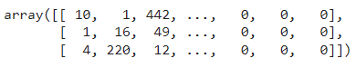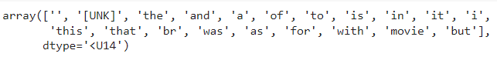







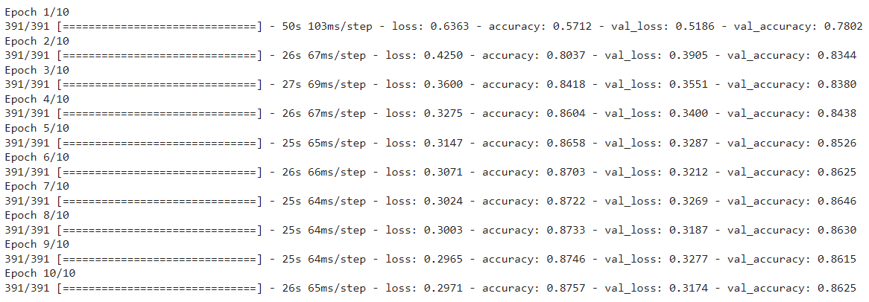



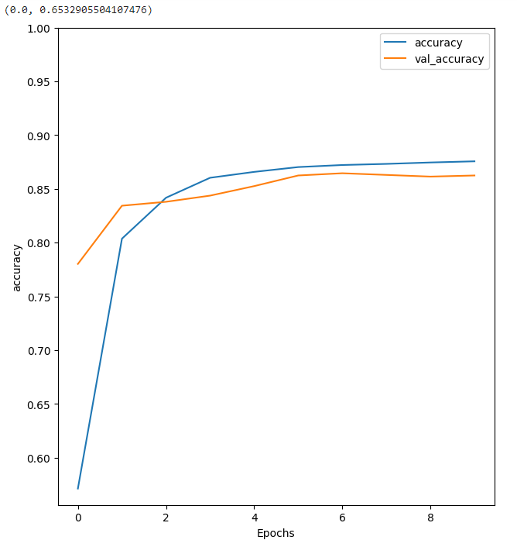

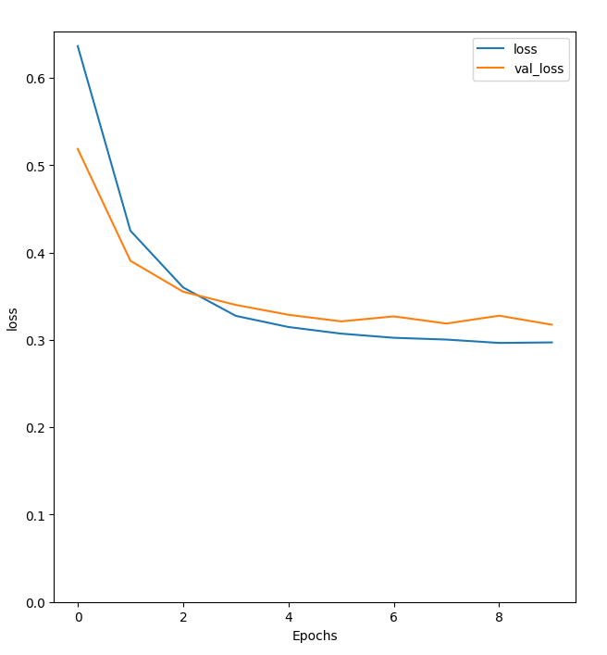

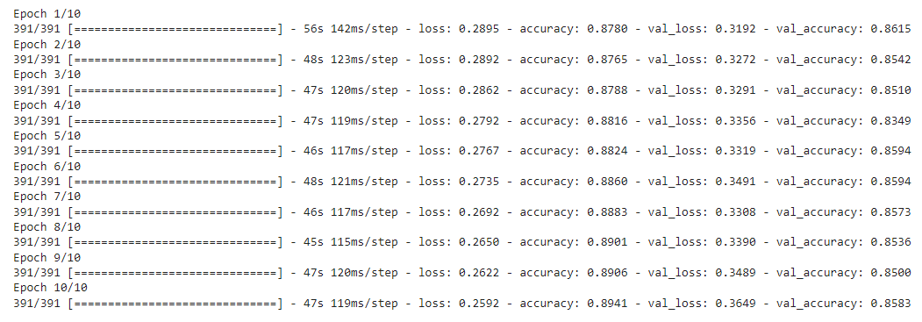



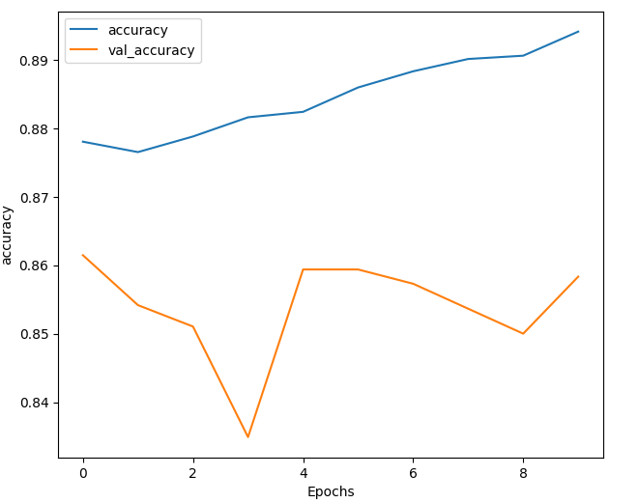

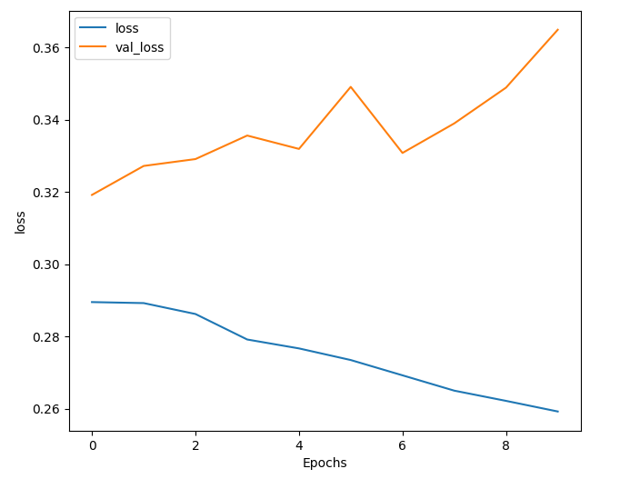

**Practical No: 8**

**Aim:** Performing encoding and decoding of images using deep autoencoder.

**Code:**

import keras

from keras import layers

from keras.datasets import mnist

import numpy as np

encoding_dim=32

#this is our input image

input_img=keras.Input(shape=(784,))

#"encoded" is the encoded representation of the input

encoded=layers.Dense(encoding_dim, activation='relu')(input_img)

#"decoded" is the lossy reconstruction of the input

decoded=layers.Dense(784, activation='sigmoid')(encoded)

#creating autoencoder model

autoencoder=keras.Model(input_img,decoded)

#create the encoder model

encoder=keras.Model(input_img,encoded)

encoded_input=keras.Input(shape=(encoding_dim,))

#Retrive the last layer of the autoencoder model

decoder_layer=autoencoder.layers[-1]

#create the decoder model

decoder=keras.Model(encoded_input,decoder_layer(encoded_input))

autoencoder.compile(optimizer='adam',loss='binary_crossentropy')

#scale and make train and test dataset

(X_train,_),(X_test,_)=mnist.load_data()

X_train=X_train.astype('float32')/255.

X_test=X_test.astype('float32')/255.

X_train=X_train.reshape((len(X_train),np.prod(X_train.shape[1:])))

X_test=X_test.reshape((len(X_test),np.prod(X_test.shape[1:])))

print(X_train.shape)

print(X_test.shape)

#train autoencoder with training dataset

autoencoder.fit(X_train,X_train,

epochs=50,

batch_size=256,

shuffle=True,

validation_data=(X_test,X_test))

encoded_imgs=encoder.predict(X_test)

decoded_imgs=decoder.predict(encoded_imgs)

import matplotlib.pyplot as plt

n = 10 # How many digits we will display

plt.figure(figsize=(40, 4))

for i in range(10):

# display original

ax = plt.subplot(3, 20, i + 1)

plt.imshow(X_test[i].reshape(28, 28))

plt.gray()

ax.get_xaxis().set_visible(False)

ax.get_yaxis().set_visible(False)

# display encoded image

ax = plt.subplot(3, 20, i + 1 + 20)

plt.imshow(encoded_imgs[i].reshape(8,4))

plt.gray()

ax.get_xaxis().set_visible(False)

ax.get_yaxis().set_visible(False)

# display reconstruction

ax = plt.subplot(3, 20, 2*20 +i+ 1)

plt.imshow(decoded_imgs[i].reshape(28, 28))

plt.gray()

ax.get_xaxis().set_visible(False)

ax.get_yaxis().set_visible(False)

plt.show()

**Output:**

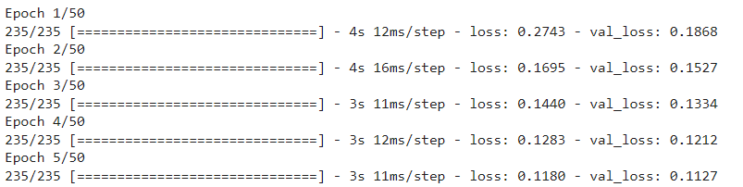

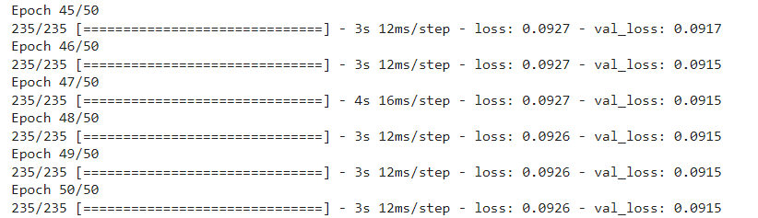

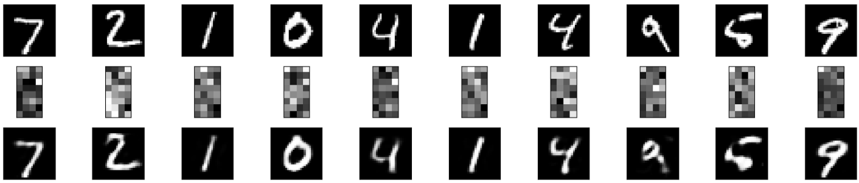

**Practical No: 9**

**Aim:** Implementation of convolutional neural network to predict numbers from number images.

**Code:**

import tensorflow as tf

mnist = tf.keras.datasets.mnist

(X_train, y_train), (X_test, y_test) = mnist.load_data()

X_train.shape

y_train.shape

X_test.shape

y_test.shape

import matplotlib.pyplot as plt

plt.imshow(X_train[2])

plt.show()

plt.imshow(X_train[2], cmap=plt.cm.binary)

X_train[2]

X_train = tf.keras.utils.normalize(X_train, axis=1)

X_test = tf.keras.utils.normalize(X_test, axis=1)

plt.imshow(X_train[2], cmap=plt.cm.binary)

print(X_train[2])

import tensorflow as tf

import tensorflow.keras.layers as KL

import tensorflow.keras.models as KM

inputs = KL.Input(shape=(28, 28, 1))

c = KL.Conv2D(32, (3, 3), padding="valid", activation=tf.nn.relu)(inputs)

m = KL.MaxPool2D((2, 2), (2, 2))(c)

d = KL.Dropout(0.5)(m)

c = KL.Conv2D(64, (3, 3), padding="valid", activation=tf.nn.relu)(d)

m = KL.MaxPool2D((2, 2), (2, 2))(c)

d = KL.Dropout(0.5)(m)

c = KL.Conv2D(128, (3, 3), padding="valid", activation=tf.nn.relu)(d)

f = KL.Flatten()(c)

outputs = KL.Dense(10, activation=tf.nn.softmax)(f)

model = KM.Model(inputs, outputs)

model.summary()

model.compile(optimizer="adam", loss="sparse_categorical_crossentropy", metrics=["accuracy"])

model.fit(X_train, y_train, epochs=5)

test_loss, test_acc = model.evaluate(X_test, y_test)

print("Test Loss: {0} - Test Acc: {1}".format(test_loss, test_acc))

**Output:**

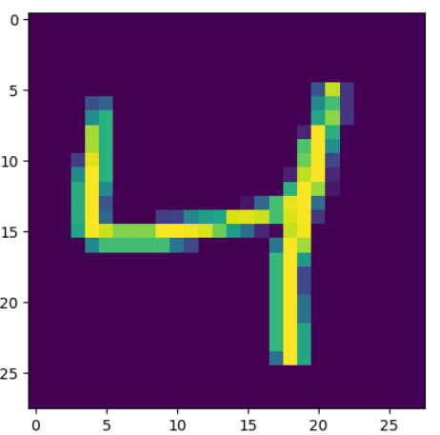

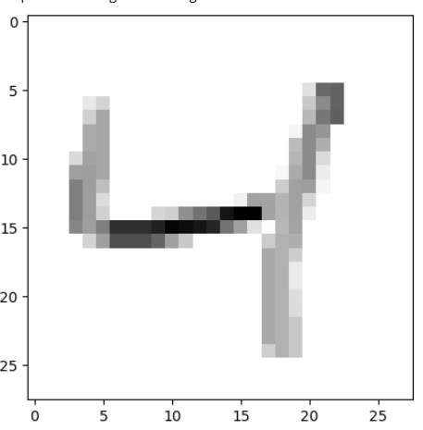

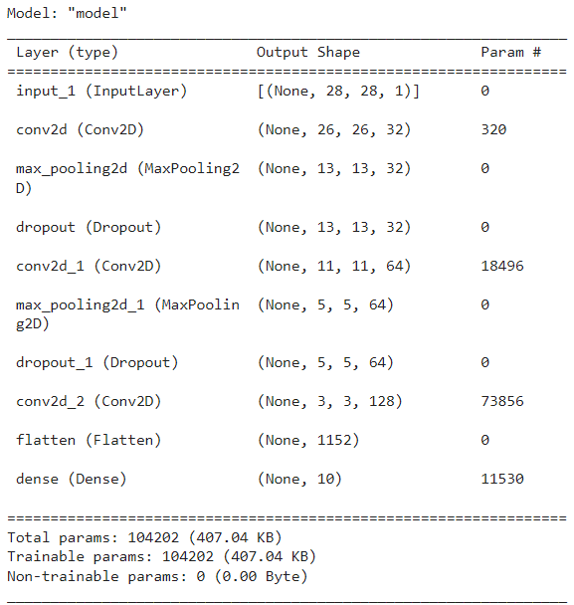

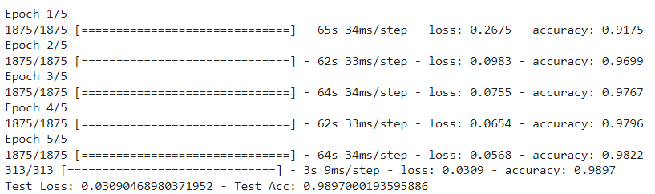

**Practical No: 10**

**Aim:** Denoising of images using autoencoder.

**Code:**

import keras

from keras.datasets import mnist

from keras import layers

import numpy as np

from keras.callbacks import TensorBoard

import matplotlib.pyplot as plt

(X_train, _), (X_test, _) = mnist.load_data()

X_train = X_train.astype('float32') / 255.

X_test = X_test.astype('float32') / 255.

X_train = np.reshape(X_train, (len(X_train), 28, 28, 1))

X_test = np.reshape(X_test, (len(X_test), 28, 28, 1))

noise_factor = 0.5

X_train_noisy = X_train + noise_factor * np.random.normal(loc=0.0, scale=1.0, size=X_train.shape)

X_test_noisy = X_test + noise_factor * np.random.normal(loc=0.0, scale=1.0, size=X_test.shape)

X_train_noisy = np.clip(X_train_noisy, 0., 1.)

X_test_noisy = np.clip(X_test_noisy, 0., 1.)

n = 10

plt.figure(figsize=(20, 2))

for i in range(1, n + 1):

ax = plt.subplot(1, n, i)

plt.imshow(X_test_noisy[i].reshape(28, 28))

plt.gray()

ax.get_xaxis().set_visible(False)

ax.get_yaxis().set_visible(False)

plt.show()

input_img = keras.Input(shape=(28, 28, 1))

x = layers.Conv2D(32, (3, 3), activation='relu', padding='same')(input_img)

x = layers.MaxPooling2D((2, 2), padding='same')(x)

x = layers.Conv2D(32, (3, 3), activation='relu', padding='same')(x)

encoded = layers.MaxPooling2D((2, 2), padding='same')(x)

x = layers.Conv2D(32, (3, 3), activation='relu', padding='same')(encoded)

x = layers.UpSampling2D((2, 2))(x)

x = layers.Conv2D(32, (3, 3), activation='relu', padding='same')(x)

x = layers.UpSampling2D((2, 2))(x)

decoded = layers.Conv2D(1, (3, 3), activation='sigmoid', padding='same')(x)

autoencoder = keras.Model(input_img, decoded)

autoencoder.compile(optimizer='adam', loss='binary_crossentropy')

autoencoder.fit(X_train_noisy, X_train,

epochs=3,

batch_size=128,

shuffle=True,

validation_data=(X_test_noisy, X_test),

callbacks=[TensorBoard(log_dir='/tmo/tb', histogram_freq=0, write_graph=False)])

predictions = autoencoder.predict(X_test_noisy)

m = 10

plt.figure(figsize=(20, 2))

for i in range(1, m + 1):

ax = plt.subplot(1, m, i)

plt.imshow(predictions[i].reshape(28, 28))

plt.gray()

ax.get_xaxis().set_visible(False)

ax.get_yaxis().set_visible(False)

plt.show()

**Output:**

